**Music supplement to the Lutezine to Lute News 141 (April 2022): Sources of Studenten Tantz - John come kiss me now, The Buffons/Les Bouffons, Si vous estes belle & Branle de la Torche**

**Studenten Tantz**

Fifty seven settings of a *Studenten tantz*, all but thirteen (S1, 9, 24, 25, 27, 28, 37, 39, 40, 45, 46, 53 & 55) in German tablature sources, are edited here, grouped by tonality: nine in C minor, four in D minor, twelve in F minor and thirty two in G minor, assuming a lute at G pitch. The settings are in duple time most (not S1, 9, 24, 25, 27, 31, 32, 35, 40, 45, 49, 53 & 55) followed by a triple time after dance variously called *Nach Tantz, Proportio, Saltarello* or *Sprung*. The title *Studenten Tantz* originally suggested to me a type of exercise for lute students to practice but on reflection it would be surprising that over sixty settings of the same music circulated quite so widely for this purpose as all but two (S25, 53) are based on the same rudimentary descant and simple ground. As an alternative, the title may mean it was a popular tantz for university students to dance to, as suggested by three settings called *Der Wittenberger Studenten tantz* in the same source (S8, 22 & 52) that specifically refers to students of Wittenberg University, which was associated with Martin Luther in the early sixteenth century. However, another possibility is that they are settings of a popular song about the plight of students, suggested by the title *Worumb/Warumb seindt die Studenten* (S1, 16 and 17) found in three different sources. One of the sources is the Petrus Fabritus lute book that includes eight lute solos of the music for Studenten tantz, only one of them with the title *Worumb seindt die Studenten* and elsewhere in the manuscript (f. 74v) is a song of six verses beginning 'Worumb seind die Studenten, so leiden woll gehordt',[1] set to a melody in mensural notation unrelated to the instrumental settings of the Studenten tantz. But all three sources with the *Worumb* *seindt die Studenten* title are from around the turn of the sixteenth century, late in the sequence of sources of the *Studenten tantz* and so it seems unlikely that the music was originally associated with the song text, rather that the text came later.

The majority of sources use the title *Studenten Tantz* or similar - some *alio modo* or *aliter* referring to the title of the previous piece in the source, although a few can be recognised as the same music but with other titles: *almande, chorea, Hellena tantz, teutscher tantz*, or untitled. Three sources that are nearly identical in the duple time section are called *Helena Tantz* (S30, S31 & S35), that are a variant with an added C strain. However S31 adds a C strain and a repeat on the ground IV/i-V/i/V-i-I, followed by a triple time reworking of all three strains, but the triple time section of S30 is an unrelated descant with repeat on the second half of the romanesca ground, whereas S35 omits a C strain and the triple time section altogether. S55 in the Thomas Dallis lute book is called *Almande* and is a pastiche of a statement of the tune *Une jeune fillette*,[2] followed by an untitled setting of the Studenten tantz.

The descant or tune, most clearly seen in the unadorned setting S31 copied around 1545 (although the B strain is a variant) is an arched rising and falling phrase in the 4-bar A strain (tonic-supertonic-mediant/ supertonic/tonic-supertonic) followed by a descending phrase (tonic or mediant-supertonic-tonic/leading note-tonic) for the B strain.[3] The descant is clearly discernable in most of the settings in G minor, but more obscure in the settings in the other three tonalities, possibly suggesting they might be duet or ensemble parts (see below).

The descant is set to an eight-bar ground divided into two four-bar halves or A & B strains usually just one of each but sometimes with repeats of A, B or both. The ground is a variant of the passamezzo antico with a bar each of A: i-V-*-V and B: i or III-VII-*-I (chords on scale degrees, lower case minor and upper case major chords)[4] where the * represent a range of harmonic variants in positions 3 and 7 as well as additional harmonies in passing elsewhere creating interest and deserving of the *sehr lieblich* - very lovely - in Heckel's title (S31).[5]

Most of the sources were probably played as lute solos, but some are presumed to be duet or ensemble parts from the clues in the titles. One pair, S6 (in C)[6] and S54 (in G), clearly form a duet as they are found in Mathäus Waissel's book of duets for lutes a fourth apart (although the title page says they can also be played as lute solos too).[7] The words *discantus* (S24, in F), *tenor* (S51, in G) and *bassus* (S3, 5, 7 & 9 all in C) in the titles of others are indicative of parts rather than referring to different sizes of lute to play them on as solos. Some may be orphan parts (S5), although the missing parts may be in other sources without clues in the title. Others are adjacent in the same source, such as the bassus S9 and discantus S24 also adjacent to the untitled S46 and in three different tonalities suggesting a solo and a duet or three ensemble parts, but there is no rhythmic variety, alternating melodic sequences in different bars or contrasting writing in upper and lower register between them characteristic of the known duet repertoire. The bassus S3 and tenor S51 are also adjacent in one source but again do not have alternating figuration or rhythmic patterns. The bassus S7 (in C) is one of eight versions in all four tonalities in the Fabritus lute book, of which only two others give any indication they are not solos, the titles of S14 (in F) and S29 (in G) including 'aus dem D' [=discant?] and 'aus dem C' [=contratenor?], respectively, which could mean all three are ensemble parts. Similarly, the letters D [= discant?] and B [=bassus] are found in the titles of S10 and S13, on the same page of one source, but they are in the same tonality and discant and bassus parts of a unison duet seem unlikely due to clashes of harmony in bars 5 & 13 and the bars of unison figuration elswhere (bar 19). Others possible pairs a tone or more apart do not indicate that they are duet parts in the title but are found adjacent (or nearby) in the same source, and so could be duet parts, such as S19 and S48, or S20 and S50 in the Arpin lute book. All the sources are grouped by tonality here for ease of comparison, and possible duet pairs and consort parts are cross referenced in the worklist and briefly described in the text, intended as a step towards future attempts to distinguish solos from duets and ensembles.

**Cognates in C minor:** chords usually A: c-G-*-G & B: Eb or c-Bb-*-C

**S1.** D-Dl M 297, p. 147 *Warumb seindt die Studenten Ein Tantz* 7

**S2.** CH-Bu F.IX.70, p. 247 *XXXI Studiosorum chorea alio modo - proportio* 7

**S3.** PL-Kj W 510, f. 16r *Studenten dantz Bassus - Nachdantz* - cf. S51 7

**S4.** DK-Kk Thott 841,4o, f. 76r iv *Aliter* - [proportz] - *Proport* 8

**S5.** CH-Bu F.X.11, f. 18v *Studenten tantz. Bassus - Proportio* 8

**S6.** Waissel 1592b, sig. A1v *1. Tantz - Sprung* - cf. S54 8

**S7.** DK-Kk Thott 841,4o, f. 76r iii *Der Bass im* *Studenten dantz* - [proportz] 9

**S8.** NL-At 208.A.27, ff. 63v-64r *Der Wittenberger Studenten tantz*

*- Saltarello LIX* 9

**S9.** D-KNh R.242, f. 218r *Bassus* - cf. S25 10

**Cognates in D minor:** chords usually A: d-A-*-A & B: F-C-*-D

**S10.** D-Sl G.I.4/I, f. 39r ii untitled *D. -* [Nachdantz] *D.* - cf. S13 10

**S11.** DK-Kk Thott 841,4o, f. 78v ii *Alio modo* - [proportio] 11

**S12.** DK-Kk Thott 841,4o, ff. 78v-79r *Alio modo* - [proportio] 11

**S13.** D-Sl G.I.4/I, f. 39r i *Studenten dantz B. - Nachdantz B.* - cf. S10 12

**Cognates in F minor:** chords usually A: f-C-*-C & B: Ab or f-Eb-*-F

**S14.** DK-Kk Thott 841,4o, f. 76r i *Der Studenten dantz auß dem D*

- [proportz] 12

**S15.** DK-Kk Thott 841,4o, f. 76r v *Studenten dantz - Proport* 13

**S16.** CH-Bu F.IX.70, p. 274 CVIIII *Warumb seind die Studenten voll* 13

**S17.** DK-Kk Thott 841,4o, f. 78v i *Worumb seindt die Studenten so leiden*

- [proportio] 14

**S18.** CH-Bu F.IX.70, p. 247 *XXXII Studiosorum chorea alio modo*

*- proportio* 14

**S19.** D-Z 115.3, f. 4v *Studiosorum* - [proportio] - cf. S48 15

= CZ-Pu 59r.469, f. 9v *Tanecz Studiosorum* - [proportio]

**S20.** D-Z 115.3, f. 6v *Tanec giney tyz Studiosorum* - [proportio] - cf. S50 15

= CZ-Pu 59r.469, f. 11v *Gyney Tanecz tyz Studiosorum* - [proportio]

**S21.** D-Mbs 1512, ff. 47v-48r *Ein ser gueter dannts hd*

*- Der auf vnnd auff hd* 16

**S22.** NL-At 208.A.27, f. 64r *Der Wittenberger Studenten tantz*

*- Saltarello LX* 17

**S23.** CH-Bu F.IX.70, p. 255 *XLVIIII Chorea - Proportio* 18

**S24.** D-KNh R.242, f. 217v ii *Discantus - Tannenbeum* - cf. S9 18

**S25.** A-SPL KK 35, p. 52 *Studenten Dantz* - different 18

**Cognates in G minor:** chords usually A: g-D-*-D & B: Bb or g-F-*-G

**S26.** CH-Bu F.X.11, ff. 20r-20v *Studenten tantz - Nachdantz* 19

**S27.** NL-Lt 1666, f. 413r *Den Studenten dans* - untitled 20

**S28.** S-B PB fil.172, f. 11r *Teutscher dantz - Nachdans* 21

**S29.** DK-Kk Thott 841,4o, f. 76r ii *auß dem C* - [proportz] 21

**S30.** Heckel Tenor 1556/R1562, pp. 157-159 *Helena Tantz*

*sehr lieblich* *- Proportz darauff* 22-23

**S31.** D-MGs 115.1 Nr.631,[8] f. 5r *ein tantz* 23

**S32.** D-LEm II.6.7, sig. D3r *Studenten tantz* *Lute News* & 23

**S33.** CH-SAM 1, ff. 17r-17v *Hellenae tantz - Proportz* 24

**S34.** CH-Bu F.X.11, f. 8r *Studenten tantz - Nachdantz* 25

*- All ding ein weÿl abre mit eroig*

**S35.** CH-Bu F.X.11, f. 11v *Helena tantz* 25

**S36.** CH-Bu F.X.11, f. 17v *Studenten tantz - Proportio* 26

**S37.** PL-Kj 40143, ff. 94v-95r *Studenten Dantz*

*A 1601 ult*[im]*o Martij* - [nachdantz] 26

**S38.** CH-Bu F.IX.23, ff. 8v-9r *Studenten tantz - Nachtantz* 27

**S39.** D-MÜwl 439 (Schenckinck), f. 83v *Studenten Tantz - Proportio* 28

**S40.** PL-Kj 40159, f. 16v *Studenten dantz* *Lute News* & 28

**S41.** Newsidler 1549, sigs. h4r-h4v *Der recht Studenten Tantz*

*- Der Hupff auff* 29

**S42.** D-LEm II.2.45, f. 60r *Tantz* - [nachtantz] 30

**S43.** D-B 40141, f. 45r *Studenten Tantz - Sprung* 30

**S44.** CH-Bu F.IX.70, p. 247 *XXX Studiosorum chorea - proportio* 31

**S45.** LT-Va 285-MF-LXXIX, f. 12v *Studenten Tantz* 31

**S46.** D-KNh R.242, f. 217v untitled - *Proportio* 31

**S47.** D-W Guelf. 18.8, f. 37v *Studentendantz - Nachdantz* 32

**S48.** D-Z 115.3, f. 5r untitled - [proportio] - cf. S19 32

= CZ-Pu 59r.469, f. 10r untitled - [proportio]

**S49.** CZ-Pu XXIII.F.174, f. 13v *Chorea studiosorum* *Lute News* & 32

**S50.** D-Z 115.3, f. 7r untitled - [proportio]- cf. S20 33

= CZ-Pu 59r.469, f. 12r untitled - [proportio]

**S51.** PL-Kj W 510, f. 16r *Studenten dantz Tenor - Nachdantz* cf. S3 33

**S52.** NL-At 208.A.27, f. 64v *Der Wittenberger Studenten tantz LXI* 34

**S53.** Valerius 1626, p. 25 *Studenten Dans* - different *Lute News* & 34

**S54.** Waissel 1592b, sig. A1v *1. Tantz - Sprung* - cf. S6 35

**S55.** IRL-Dtc 410/I, p. 218 *Almande.1* 35

**Cognates for cittern:**

**S56.** CZ-Bsa G.10,1400, f. 70v *Studenten tantz - Nachtantz* - 6-course 36

**S57.** CH-D Berchter, p. 439 *Studenten dantz - Nach dantz* - diatonic 36

A-Wwilczek no. 2 *Studenten Dantz Finis 1596 - Nach Dantz* - no copy available

Keyboard: Ammerbach 1583, pp. 185-186 *Studenten Dantz* *- Proportio tripla*

**John come kiss me now**

Two short settings of the ballad/dance tune *John come kiss me now* was included in the supplement to the accompanying *Lute News* 141, repeated here as J1 & J3 together with another eighteen settings for plucked or bowed instruments and one arranged from a melody (J20). Only one setting is known for renaissance lute, a wonderful set of fifteen variations in three nearly identical versions (J2a-c). One of the three is titled *treble*, but the inclusion of harmony including the bass means that it works as a lute solo. The three provide the options of for six- seven- or ten-course lutes, in plain tablature or with right hand fingering and few or many ornaments. The other settings include two for lutes in other tunings (J1, J6), three for lyra viol (J5, J7, J8), one for keyboard (J3), all transcribed for renaissance lute here, and eleven for cittern (J4, 10-19), one diatonic in french tuning plus a transcription for chromatic cittern (J13) and the rest for chromatic cittern in italian tuning. Settings for keyboard and violin are also listed here. The music of *John come kiss me now* sets the familiar tune to the passamezzo moderno of eight notes or chords, over eight bars known as the cut-time pm (I-IV-I-V-I-IV-I/V-I), to distinguish it from the settings of the ground over sixteen bars as is usual in the quadro. J1-8 all use the same tune, although J3 and J6 have a variant in bar 4 in which the melody rises a tone rather than falling a third. However, despite all but one (J14) bearing the title *John come kiss me now*, several of the cittern settings (J11-14) use the ground but not the tune and seem like accompaniments or ensemble parts. Thomas Robinson's cittern setting (J19) is a set of variations without the tune becoming apparent, Playford's settings (J15 & 16) only quote the tune in the last variation and J5 for lyra viol comprises two statements of the ground as a melodic line only. The latest setting J9 here, dated 1684, is for 5-course baroque guitar.[9] The music associated with *John come kiss me now* seems to predate the text as the tune and ground are also found in mainly continental settings titled *Les Bouffons/ Buffins*, *Si vous estes belle* and *Branle/Ballet/Almande de la Torche* (see below) some sources of which predate the first reference to *John come kiss me now* in the 1560s.[10]

A complete text for a ballad called 'John come kiss me now' is not known but what might have been the first verse, 'Iohne, cum kis me now, Johne, cum kis me now, Johne, cum kis me by and by, And mak no moir adow' begins a moralisation continuing somewhat incongruously 'The Lord thy God I am, That Johne dois the[e] call, John representit man, Be grace Celestiall' found in Andro Hart's *A Compendious Book of Godly and Spiritual Songs* published in 1567.[11] The same first stanza followed by a different moralisation 'Peace I'm angrie now now, peace I'm angrie now, Peace I'm angrie at the heart, and known not qt <=what> to dow', followed by 'His answer to yt sam toone' in thirteen stanzas, is found in a section of 'Airs and Sonnets' added in the early seventeenth century to one of Thomas Wode's part books(a.k.a. the St Andrews Psalter), copied 1566-1592: the quintus part book now in Dublin (IRL-Dtc 412 olim MS F.5.13). The text is on f. 32v and is preceded by the tune in mensural notation with a tenor clef on f. 32r, followed by a variation (arranged for lute here as J20) - the variation is similar to the cittern settings in Boteler (J17-18). A related moralisation was published by David Herd in *Ancient and Modern Scottish Songs* (Edinburgh, Wotherspoon 1776), vol 2, p. 206.[12] The Scots poet Robert Burns later reworked both of Herd's stanzas in a poem published with music in James Johnson's *Scots Musical Museum* in 1790 - see illustration on p. 102.[13] Alexander F. Mitchell's *The Gude and Godle Ballatis* (Scottish Text Society 1897), a reprint of the 1567 edition of Andro Hart's *A Compendious Book of Godly and Spiritual Songs*, reproduced the original on pp. 158-161, and adds another contrafactum probably celebrating the fall of St Andrews castle on p. 277.[14] Finally, the first stanza is parodied in James Hogg *The Jacobite Relics of Scotland* (Edinburgh, Blackwood 1817), vol. 1, pp. 144-146: 'James, come kis me now', with the fourth/last stanza beginining 'Great James, come kiss me now, now, Great James, come kiss me now: Too long I've undone myself these years bygone, By basely forsaking you' - see illustration on p. 102.

Only one ballad is known that calls for the tune, found without music in GB-Lbl Add.15225, ff. 35v-38r (*c.*1576), titled 'A dittie most excelent for euerie man to reade that dothe intend for to amende & to repent with speede to the tune of a rich marchant man or John come kiss me now' (alternative tunes?) beginning 'Whoe loveth to live in peace & marketh euerie change'. The poem without tune indication or music was also published in *Tottel's Miscellany* 1557, p. 205 under the title 'Descripcion of an ungodly worlde', and is also found in GB-Ob Ashmole 48, f. 37v (*c.*1555-1565) and GB-Lbl Sloane 1896, f. 35v (*c.*1576), and a broadside version was registered with the Stationers' Company in 1564 but no copy is known.[15] A similar untitled tune is also used to accompany the ballad 'As the Friar he went along' in Thomas D'Urfey's *Wit and Mirth, or Pills to Purge Melancholy* 1719 vol. 5 p. 58 - see illustration on p. 102. The words 'Ioan come kisse me now, once againe for my loue, gentle Jone come kisse me now' are also set as a canon for three voices in unison in Ravenscroft *Pamelia* 1609, sig. C1v, but to a different melody, and Adam Thomson's ballad opera *The Dissappointed Gallant* 1738 included a song 'John come kiss me now' beginning 'When charming Chloe gently walks' that was published by W. Napier *A Selection of Original Scots Songs* 1792, vol. II pp. 42-43 set to unrelated music by Haydn!

John come kisse me now is mentioned mainly as a tune for dancing, and sometimes for playing or singing, in many plays and poems from the sixteenth to eighteenth century, listed chronologically here. **1600:** in Thomas Heywood's play *A Woman kill'd with Kindness*, act 1 scene 2: Jack Slime: 'I come to dance, not to quarell: Come what shall it be? Rogero?' Jenkin: 'Rogero, no: we will dance The Beginning of the World.' Sisley: 'I love no dance so well as John, come kiss me now'. **1609:** in Samuel Rowlande's? *Tis merry when Gossips meet*, the widow explains that 'No musique in the euening did we lacke, Such dauncing, Coussen, you would hardly thinke it; ... Such store of tickling galliards, I do vow; Not an old daunce, but *John, come kisse me now*'. **1611**/R1625: John Davies *The Scourge of Folly*, epigram 252: 'Three Ierkes for this but Iustice is': 'Whether a grace or guird these lines do close-in, Heath will be iudge, which shames the place it growes in. Haue I for the Schoole thou learn'st in bin loue-sicke? And makst thou me but a foole by a Schoole-tricke! O once againe for my loue, gentle Iohn come kiss me now: Mary and will.' **1621** Robert Burton's *Anatomy of Melancholy*, line 5523: 'Nothing so familiar in France, as for citizens wives and maids to dance a round in the streets, and often too, for want of better instruments, to make good music of their own voices, and dance after it. Yea, many time this love will make old men and women, that have more toes than teeth, dance *John, come kisse me now*, mask and mum'. **1640:** George Herbert *Witt's Recreation*, in 'The Sheapherad's Holiday', is found 'Roundelays - Irish hayes; Cogs and Rongs, and Peggie Ramsy; Spaniletto - The Venetto; John come kiss me now - Wilson's Fancy. But of all there's none so sprightly To my ear, as Touch me lightly'. **1649** Sir William Davenant's play *Love and Honour*, p. 7: Altesto: 'And she behaves them on the Virginals So prettily, I'ld wish no more of her, Than once to hear her play *Fortune my Foe:* Or *John come kisse me now.*' Vasco: 'Those are tunes my old widdow prisoner sings With more division than a water work When the maine pipe is halfe stopt.' **1661** Francis Kirkman's play *Tom Tyler and his Wife*,p. 5 lines 162-167: Strife: 'And where is your good man?' Tipple: 'Forsooth nought at home, he is abrod for pence.' Sturdie: 'Well, I had need to go hence, Least my good man do misse me.' Strife: 'I would teach him John come kisse me, If the dolt were mine.' **1671** anonymous *Westminster Drollery*, the song 'My name in honest Harry' begins 'The fiddlers shall attend us, And first play, *John, come kisse me*; And when that we have danc'd a round, They shall play, Hit or misse me.' **1680** in Thomas Betterton's play *Revenge*, act II ends with Mr. Dash: 'I say is there any Musick in the house?' Mrs. Dash: 'Yes, Sweet-heart, Mr Squeek's Noyse.' Mr. Dash: 'Bid 'em play then: And *John* come kiss me now, now, now, and *John* come kiss me now' and he leaves the stage dancing with the bottle in's hand, and sings, *John* come kiss me, &c. **1685** Henry Bold *Songs and Poems*, p. 148 the song/poem 'On a Barber who became a great Master of Musick' begins 'In former time 't hath been upbrayded thus, That Barbers Musick was most Barbarous, For that the Cittern was confin'd unto The Ladies fall, or *John* come kiss me now, Green sleeves and Pudding Pyes, the Punks delight, Winning of *Bolloigne, Essex*'s last good night.' **1687** John Phillips' translation of Cervantes *Don Quixote*, p. 278 'Birds with painted Wings of various Colours, hopping from Branch to Branch, all naturally singing *Walsingham*, and whistling *John come kiss me now*, enchant his Ears'. **1698/1709**: Edward 'Ned' Ward *The London Spy Compleat*, p. 46 [p. 42 in 4th ed 1753] describes 'A Vintner's Daughter, bred at the *Dancing-School*, becomes a *Bar* well, steps a Minuet finely, plays *John come Kiss me now, now, now,* sweetly upon the *Virginals*, makes a very graceful Figure, and is as *proud* as she's *handsome*'. **1728**/pub 1846Roger North *Memoires of Musick* p. 92 'And if on the other side, I may take upon me to be a fidling prophet, I may much reason declare that the time may come when some of the present celebrated musick will be in as much contempt as *John, come kiss me now, now, now* and perhaps with as much reason as any is found to the contrary at present'.[16]

**J1i.** GB-En 9769 84/1.6, p. 217 *John come kisse me now, by John Red* 37

**J1ii.** GB-En 9769 84/1.6, p. 217 *John come kisse me now, by John Red* 37

- transcribed to vieil ton

**J2a.** GB-Cu Add.3056, ff. 69v-70r *A Treble* 38-41

**J2b.** GB-Lcm loan 2019-1 welde, ff. 10v-11r *A Treble* - duet treble 42-45

**J2c.** GB-Lbl Add.38539, ff. 11v-12r *John com Kisse mee Now* 46-49

**J3.** F-Pn Rés.1186, f. 58r *John come kisse me now* 41

US-NYp Drexel 5609, p. 142 *John come kiss me now*

**J4.** US-CAh 182 (Ridout), f. 78v *John cum kisse me nou* - cittern 45

**J5.** S-N Finspong 9096.3, no. 2 *Johne come kisse me* - lyra viol (ffeff) 49

**J6i.** GB-En 9769 84/1.6 (Balcarres), p. 54 *John come kiss me now, or the buffines, John Morisons way. by mr Beck* 50

**J6ii.** GB-En 9769 84/1.6, p. 54 *John come kiss me now, or the buffines, John Morisons way. by mr Beck* - transcribed to vieil ton 51

**J7.** GB-DU Mus.10455 (Blaikie), p. 7 no. 15 *John come kiss me now* 52

- transcribed from lyra viol (defhf)

**J8.** GB-En Dep.314 no. 24 (Sutherland), p. 15 *John com kiss me nou* 52

*herp sherp* - transcribed from lyra viol (defhf) - VdGS[17] 7263

**5-course baroque guitar (feff):**

**J9.** GB-Ob C.94, f. viiir *John come kiss me De Gallot d`Irlande 1684* 53

**cittern:**

**J10.** US-CAh 181 (Otley), f. 14v *John come kisse me now*

*- John come kiss me the second way* 53

**J11.** US-CAh 179, f. 44v *John com kisse me now* 53

US-CAh 179, f. 40r *John com kisse me now* - 1 bar fragment of tablature

**J12.** US-CAh 182 (Ridout), f. 66r *John come kisse me now* 53

**J13i.** GB-En 9450 (Edwards), ff. 41r-41v *Jhon come kisse me noue -* 54

- diatonic cittern in French tuning

**J13ii.** GB-En 9450, ff. 41r-41v *Jhon come kisse me noue* 54

- transcribed for chromatic cittern in Italian tuning

**J14.** J-Tn BM-4540-n3, sig. B3r *John kiss me* 524

**J15.** Playford *Musicks Delight on the Cithren* 1666, sigs. B2v-B3r 4 *John come kiss me now* 55

**J16.** Playford *A Booke of New Lessons for the Cithren* 1652, p. 1 *First way*

*John come kiss me now - Second way John come kiss me now*

*- The third way John come kiss me* - cittern 56

**J17.** US-CAh 179 (Boteler), f. 10r *John cum kis mee now* 56

**J18.** US-CAh 179, f. 46v untitled 56

**J19.** Robinson 1609, sigs. G2v-G3r *27. Ioan come kisse me now* 57

**arranged melody:**

**J20.** IRL-Dtc 412, f. 32r *Jon com kisse me now - folows the running of it - The running of Jon com kisse me now - The letter is on the other syd* (text on 32v) 58

- arranged up a 5th from a melody in mensural notation

Cognates, for keyboard: GB-Cfm 168, pp. 23-26 *Jhon come kiss me now William Byrd*; GB-En 3296 (Sinkler), ff. 49v-52r *John come kiss me now*; GB-Lbl Add.29996, ff. 206v-209v *Jone come kiss me nowe Mr John Tomkins*. Violin: GB-En 'Patrick Cuming his Book Edinburgh 1673', pp. 40-44 untitled; Playford *Apollo's Banquet* 1670, preliminary pages; Playford *Division Violin* 1684, pp. 18-19 *11 Iohn come kiss. A Division upon a Ground by Mr. David Mell*; Playford *Division Violin* 1684, pp. 20-22 *12 Senr. Balshar's Division on a Ground. Iohn come kiss &c*; Walsh *The Division Violin* 1705, pp. 18-19 *A 2 Iohn come kiss - Violin - A Division upon a Ground by Mr. Dauid Mell - The Ground Basse* [index: *A Division on John come kiss me by Mr. Mell*]; Walsh *The Division Violin* 1705, pp. 20-21 *A 2 Senr. Balshar's Division on a Ground - Violin - Iohn come kiss &c* [index: *A Division on John come kiss me now by Signior Balshar*]; Walsh *The Division Violin* 1705, pp. 53-58 - *A new Division upon the ground Bass of John come kiss me Composd by Mr. Henr. Eccles Junr. - Bass* [index: *A Division on John come kiss me by Mr. Henr Eccels in G*]

**The Buffons/Les Bouffons**

Randle Cotgrave *A Dictionerie of the French and English Tongues* (London 1611), defines ‘Buffon’ as a ‘buffoon, ieaster [jester], synco-phant, merrie foole, sportfull companion; one that liues by making others merrie’ - so presumably including the comedians or costumed dancers who performed in court masques in England (The buffons) or ballet de cour in France (Les bouffons). The buffons also appears with other dances in the passage on dancing in the mid-sixteenth century *The Complaynte of Scotland* by Robert Wedderburn, f. 52v: 'lopene (leaping), galmonding (gambolling), stending (striding) bakuart & forduart, danand base dancis, pauuans, galzardis, turdions, braulis, and branglis, buffons, vth mony vthrit licht da(n)cis'. However, rather than a genre, Bouffons seems to be the name given to a variety of settings of a tune related to John come kiss me now set to one of four different grounds and found in English and continental sources for lute, cittern and other instruments beginning in the 1550s. The majority are for lute but the variety of settings for other instruments included here give some readers the opportunity to 'tickle a Citterne [gittern or mandore] or have a sweete stroke on the lute'.[18] The earliest cognate in the buffons tune family, although lacking the ground, is the superius voice of Clement Jannequin's chanson 'Ma peine n'est pas grande' published in Attaingnant's *Sexiesme livre* of 1545, f. 12v (see facsimile page on p. 102). Here are sixty eight (including B9a-d and B16a-c separately) instrumental settings from the bouffon tune family grouped into four tonalities, of which most, fifty two, are titled *boufons* or similar(*boffons*,[*Les*] *bouffon*[*s*]*, boufons* [*The*] *buffins*, *il bufon*, *buffonde*, [*Les*] *buffons*), plus examples that are untitled or bear alternative titles,[19] including *the anticke/thantik* (B1, 35), *De Doot* (B5), and *La Chasse* (B3, 8, 26). They are all in common time, and five (B2, 7, 10, 13, 19) all but one in the Würstisen lute book from Basel, adding a reworking of the music as a triple time after dance. For other cognates see Si vous estes belle and Ballet/ branle/ allemande de la Torche, below. The settings are found in thirty sources (fifteen for lute) from England, France, Germany, (one from Italy is unrelated), The Netherlands, Scotland, Sweden and Switzerland. Multiple settings are found in some sources, for example ten in Thysius (B3, 4, 5, 8, 18, 26, 27, 28, 29, 31) and six in F-Pn Rés.941 (B12, 14, 22, 23, 33, 34). In addition, John Ward listed a total of over 250 settings, mainly songs, in the bouffon tune family from the 16th to 20th century and classified them into seven groups and twenty-four sub-families.[20] The tune related to John come kiss me now is not apparent in all sources despite being titled Bouffons - it is clearly heard in B1-3, 5, 7, 10 & 11for lute but less obviously in others and some are just tuneless figuration on the ground. The lute sources are set to either the passamezzo moderno (B1-5, 7, 9-12, 16-19, 23-25 & 30) or passamezzo antico (8, 13, 14, 20-22, 26-29 & 31-34), except B15 is to the bergamasca and B6 is an unrelated ground. B32 & 33 use the passamezzo antico proper (with III at position 5) and the rest are all the variant with i instead of III at position 5.

B9b and B16a are parts of a duet for lutes a fourth apart in Heckel, concordant, respectively, with B9c and B16b in NL-At 208.A.27, B9d and B16c in PL-Kj W 510 and B9a in the Wecker Tenor book - the Discant book is lost and as B9d is nearly identical to B9a including right hand fingering dots, it is possible that the settings in PL-Kj W 510 were copied from Wecker and so B16c, which is titled *disc*[ant], is probably the missing Wecker Discant part.

Twenty five sources here are for plucked instruments other than lute, including pavane/galliard pairs for gitterne (B37-38) and for cittern (B55/56/60, B57/61 & B58/62). Five distinct settings are for gittern/renaissance 4-course guitar (B35-39/40). Four distinct settings for 4-course mandore (B41-43 on the passamezzo moderno and B44 on a unique ground). Nineteen settings are for cittern (B45-63), all but two (B51, 59) in printed sources and all but one (B59, the best cittern setting!) for diatonic cittern. They are all quite similar although few are concordant - nearly identical pairs are B58 and B60 as well as B39 and B40. The strains are mostly set to the passamezzo moderno or alternating passamezzo moderno and romanesca apart from being grouped into two tonalities a fourth apart.[21] Two (B46, 49), of those in the higher set (eight, B45-52) are labelled *superius* in the title and three of the lower set (eleven, B53-63) include *bassus* in the title (B52, 53, 63). The same superius/bassus pairs are adjacent in the prints of Phalèse & Bellère 1570 (B49, 52) and Kargel 1578 (B46, 63), suggesting a duet for two citterns a fourth apart, but curiously in the revised and expanded 1582 edition of Phalèse & Bellère the bassus is included but not the superius. In fact all but one (B59) of the cittern sources in the upper or lower sets are similar and comprise chord sequences without an obvious tune so that they are more like ensemble parts rather than solos.

**In F:**

**B1.** US-Ws V.a.159 (Giles Lodge), f. 7r *The Anticke* 60

**B2.** CH-Bu F.IX.70, p. 240 *XII Alio modo Les bouffons - Proportio* 60

**B3.** NL-Lu 1666, f. 1r *La Chasse* [The hunt] 61

**B4.** NL-Lu 1666, f. 1r untitled 61

**B5.** NL-Lu 1666, f. 337r *De Doot* [Death] 61

**B6.** Barbetta *Intavolatura di Liuto* 1585, p. 18 *Balletto d’Inghilterra deta*

*il Bufon* 62

**B7.** CH-Bu F.X.11, ff. 19v-20r *Les buffons - Proportio* 62

**B8.** NL-Lt 1666, f. 2r i *La Chasse* 63

**B9a.** Wecker Tenor 1552, sig. h2v *XXXIIII. Les Bouffons* *Tenor* - lute II 63

**B9b.** Heckel Tenor 1556/1562, pp. 83-84 *Les Bouffon* - lute II 64

**B9c.** NL-At 208.A.27, f. 45r *Les Buffons Wolffgang Heckels XXII* 64-65

**B9d.** PL-Kj W 510, f. 39v *Les Bouffons* 65

**B10.** CH-Bu F.IX.70, p. 239 *XI Les bouffons - Proportio* 66

**B11.** Arbeau 1589, ff. 99r & 99v *Air des Bouffons* - arranged melody 66

**B12.** F-Pn Rés. 941, f. 2r ii *autre bouffons* [?]*fact* 77

**In C:**

**B13.** CH-Bu F.IX.70, p. 241 *XIIII Alio modo Les bouffons - Proportio* 66

**B14.** F-Pn Rés. 941, ff. 42v-43r [Bou]*ffons* 67

**B15.** GB-En Adv.5.2.18 (Straloch), p. 1 *The buffins* 67

**B16a.** Heckel Discant 1556/1562, pp. 107-109 *Les Bouffon* - lute I 68

**B16b.** NL-At Ms. 208.A.27, f. 45v *Les buffons*

*Wolffgang Heck. XXIII* 68-69

**B16c.** PL-Kj W 510, f. 49r *Les Bouffons - Disc*[ant]. 69

**B17.** IRL-Dtc 408/II, p. 104 *Buffons* 71

**B18.** NL-Lu 1666, f. 351v *Boter op de pensen* [Butter on the belly] 71

**B19.** CH-Bu F.IX.70, p. 240 *XIII Alio modo les bouffons - Proportio* 72

**B20.** D-B Hove 1, f. 161r *Bouffons* 73

**B21.** D-B Hove 1, f. 160v ii *Bouffons* 73

**B22.** F-Pn Rés.941, f. 2v i [Bou]*ffons* [?]*fact* 73

**B23.** F-Pn Rés.941, f. 2v ii [Bou]*ffons* [?]*fact* 73

**B24.** S-B PB fil.172 (Per Brahes), f. 10r *Les Boffons* 74

**B25.** CH-Bu F.IX.70, p. 286 *Bouffons* 74

**B26.** NL-Lt 1666, f. 3r i *La Chasse* 75

**B27.** NL-Lt 1666, f. 3r ii untitled 75

**In D:**

**B28.** NL-Lt 1666, f. 2r ii untitled 75

**B29.** NL-Lt 1666, f. 2r iv untitled 76

**In G:**

**B30.** D-B Hove 1, f. 160v i *Bouffons* 76

**B31.** NL-Lt 1666, f. 2r iii untitled - G pa 74

**B32.** IRL-Dtc 410/I (Dallis), p. 3 *boufons* 77

**B33.** F-Pn Rés. 941, f. 43v [Autr]*e* [bouffons] 77

**B34.** F-Pn Rés. 941, f. 2r i [Bou]*ffons* 77

**Gittern (fef):** - playable on 2nd to 5th courses of lute

**B35.** US-N Hub osborn 13, f. 44r *thantik* 75

**B36.** Morlaye I 1552, ff. 23v-24r *Buffons* 78

**B37.** Phalèse & Bellère *Guiterna* 1570, f. 57v *Pavane des Bouffons* 78

**B38.** Phalèse & Bellère 1570, f. 58r *Gaillarde des Bouffons* 80

**B39.** Phalèse & Bellère 1570, ff. 59v-60r *Almande*

*Les Bouffons - Plus diminuée* 80

**B40.** Le Roy 1569?, ff. 15r-15v *Les Bouffons - Plus diminuée -* gitterne[22] 81

**Mandore (hfhf):** - transcribed for lute, and in C assuming lute at G pitch)

**B41.** GB-En Adv.5.2.15 (Skene), p. 177 untitled 82

**B42.** GB-En Adv.5.2.15, p. 178 untitled 82

**B43.** GB-En Adv.5.2.15, p. 181 *The fowrth measure of the Buffins* 82

**B44.** US-R Sibley 96 L 973, f. 20v *10. boffonde* 83

**Diatonic cittern in french tuning: (**except B41)

**B45.** Morlaye IV 1552, f. 28v *Boufons* 83

first fret absent in original tablature here adjusted to include it

**B46.** Kargel *Renovata* 1578, sig. K1r i *67 Les Bouffons superius* - diatonic 83

**B47.** Vreedman 1568, f. 2r *Les Bouffons* 84

**B48.** Vreedman 1568, f. 2r *Autrement* 84

**B49.** Phalèse & Bellère *Hortus Cytharae* 1570, ff. 23v-24r *Les Bouffons.*

*Superius - Plus diminuee* 84

**B50.** Le Roy & Ballard 1564, ff. 14v-15r *Les Bouffons*

*- Bouffons plus diminuée* 85

**B51.** GB-En 9450, f. 41r *The buffins* 85

**B52.** Phalèse & Bellère 1570, ff. 24v-25r *Les Bouffons Bassus*

- *Plus diminuee* 86

**B53.** Phalèse & Bellère *Hortulus Cytharae* 1582, f. 69r *Bouffons Bassus* 86-87

**B54.** Le Roy & Ballard 1565, ff. 8v-9r *Les Bouffons*

*- Bouffons plus diminuée* 87

**B55.** Phalèse & Bellère 1570, f. 25r *Pavane des Bouffons* 88

**B56.** Phalèse & Bellère 1570, f. 25v *Autrement* 88

**B57.** Kargel 1578, sig. I4v i *65 Pavane des Bouffons* 88

**B58.** Le Roy & Ballard 1565, ff. 9v-10r *Pavane des Bouffons* 89

**B59.** US-CA Mus.181, f. 39v *bufons* - chromatic italian tuning 89

**B60.** Phalèse & Bellère 1570, ff. 25v-26r *Gaillarde des Bouffons* [A]

*- Autrement* [B] 90

**B61.** Kargel 1578, sig. I4v ii *66. Gaillarde des Bouffons* 90

**B62.** Le Roy & Ballard 1565, ff. 10v-11r *Gaillarde des Bouffons* 91

**B63.** Kargel 1578, sig. K1r ii *68 Les Bouffons Bassus* 91

For keyboard: D-B 40089 (Nörmiger), *131 Maschkarj Tantz - Sprungck Drauff*; GB-Lbl Add.23623, ff. 22v-27v *Les Bouffons van Jan Bull: Doctr:*; Paix 1583, ff. 172v-173r *Ballo Anglese - Saltarello*. Instrumental ensemble à 4: Estrés 1559, f. 4v *Les Bouffons*; Phalèse & Bellère 1571, f. 2v *Les Bouffons*; Mainerio *Il Primo Libro de Balli a quatro voci* 1578, p. 20 *Ballo Anglese - Saltarello*; Phalèse & Bellère 1583, f. 23v *Ballo Anglese - Saltarello*. Not the same tune or ground: GB-Lbl Add.29283-5, no. 53 *Le Bouffon*; GB-Lbl Roy.App.59-62, f. 20r *El bufon*

**Si vous estes belle**

Another early member of the buffons tune family is titled *Si vous estes belle* found first in a lute print of Phalèse published in 1549 that includes two settings in different tonalities and to different grounds. No song setting or text is known but instrumental arrangements with the same title for lute or cittern (SV3) are found some with a tune related to John come kiss me now (SV1, 4, 6ic) and set to either the passamezzo antico/romanesca[23] (SV1-3, 5, 7) or passamezzo moderno ground (SV4, 6 plus reprise, and the B strain of SV2). SV6 (and reprise) comprises four settings in different tonalities, leading Todd Lane to suggest a lute quartet relationship.[24] The scribe for some reason labelled three of the four parts incorrectly and Lane reassigned the parts labelled 'Bassus' as superius, 'Tenor' as bassus and 'Superius' as tenor, the 'Contratenor' remaining unchanged, in order that the parts fit together on four lutes at appropriate pitches (Lute I in A for Superius, Lute II in G for Contratenor, Lute III in E for Tenor and Lute IV in D or Bassus). The final source is SV7 found on a single page of the Dallis lute book as five short settings in four different tonalities. It seems to be intended as a quintet for five lutes (pitched at A, tenor at E, bassus 1 at D and bassus 2 at B), given the titles *sup*[erius], *T*[enore] *Bass*[us] and the last *In 5 partes*. However, as copied the parts do not fit together and comprise mainly unison figuration as well as harmonic clashes in bar 1 between F major in SV7b and D minor in the other four and in bar 5 between F major in SV7a & d, D minor-F major in SV7b & c and F major-D minor in SV7e.[25] Regarding tonalities, the implied keys of the tablature notation matches in the two parts titled *tenor* (6c <reassigned> & 7c), the two *superius* (6a & 7b) and the three *bassus* (SV5, 6d & 7), the shared tonalities further suggesting that SV6 and SV7, as well as SV5, are ensemble parts. It is also noteworth that SV2, a solo setting that is different to the quartet parts in the same manuscript, is concordant with the superius of the quintet in Dallis (SV7b) as well as a setting titled *Bouffons* in the French manuscript Rés.941 (see B22, above). Also the Bassus of the quintet in Dallis (SV7d) is concordant with a setting of *bouffons* also in Dallis (B32) as well as another setting of bouffons again in the French manuscript Rés.941 (B33).

**SV1.** Phalese 1549, sig. B3r *Si vous estes belle* - in C 69

**SV2.** NL-Lt 1666, f. 376r *Si vous estes belle - La Reprinse* - in C 74

**SV3.** Phalèse 1582, ff. 69v-70r *Si vous estes belle Almande* - cittern 78

**SV4.** Phalese 1549, sig. I4r *Si vous estes belle* - Smith[26] no. 3 - in Eb 78

**SV5.** CH-Bu F.IX.23, ff. 23r-23v *Si vous este bello Bass - Saltarello sua* - G 92

**SV6ia.** NL-Lt 1666, f. 365v ii [Si vous estes belle] *Bass*[us] 94

- Lane/Lundgren[27] 12a Superius

**SV6ib.** NL-Lt 1666, f. 366r ii [Si vous estes belle] *Contrat*[enor] 94

- Lane 12a Contratenor

**SV6ic.** NL-Lt 1666, f. 365v i *Si vous estes belle. Sup*[eriu]*s* 95

- Lane/Lundgren 12a Tenor

**SV6id.** NL-Lt 1666, f. 366r i[Si vous estes belle] *Tenor* 95

- Lane/Lundgren 12a Bassus

**SV6iia.** NL-Lt 1666, f. 366v ii [Reprinse Si vous estes belle] 96

- Lane/Lundgren 12b Superius

**SV6iib.** NL-Lt 1666, f. 367 i [Reprinse Si vous estes belle] 96

- Lane/Lundgren 12b Contratenor

**SV6iic.** NL-Lt 1666, f. 366v i *Reprinse* [Si vous estes belle] 97

- Lane/Lundgren 12b Tenor

**SV6iid.** NL-Lt 1666, f. 366v iii [Reprinse Si vous estes belle] 97

- Lane/Lundgren 12b Bassus

**SV7a.** IRL-Dtc 410/I, p. 133 i *Pauen si vous* 98

**SV7b.** IRL-Dtc 410/I, p. 133 ii [Pauen si vous] *Sup*[erius] 98

**SV7c.** IRL-Dtc 410/I, p. 133 iii [Pauen si vous] *T*[enor?] 98

**SV7d.** IRL-Dtc 410/I, p. 133 iv [Pauen si vous] *Bass*[us] 99

**SV7e.** IRL-Dtc 410/I, p. 133 v [Pauen si vous] *In 5 partes* 99

**Branle de la Torche**

Settings of music ralated to Les Bouffons that is titled *Ballet/ Branle/ Allemande de la Torche* are also included here. Torchlit processions were part of court masques and ballets, such as in 1512 when Henry VIII ‘with a xi other were disguised, after the maner of Italie, called a maske, a thyng not seen afore in Englande ... & after the banket doen, Maskers came in, with sixe gentlemen disguised in silke bearyng staffe torches, and desired the ladies to daunce’.[28] The famous painting in the National Portrait Gallery in London celebrating the life of Sir Henry Unton (*c.*1558-1596) portrays torch bearers with dancers and musicians in a procession entering the hall around a mixed consort (see illustration). So T1-8 here may be settings of music that originally accompanied torchlit processions in ballets. All but one (T8) of the eight settings here are related (T2 & T3 are concordant) and use a tune similar to John come kiss me now,[29] set to either the passamezzo antico (T5), the common variant of it with i rather than III in bar 5 (T4, T6 & T7) or another variant of it with IV instead of i in bars 3 and 7 (T2 & T3). T1 is an arrangement of the melody in Arbeau *Orchesographie* of 1589 to fit the passamezzo antico, but despite the similar title, T8 has an unrelated tune extended to twelve bars and is set to an extended romanesca ground (III-VII-i-V-III-VII-i/V-I-i-I-i/V-I). The title *Bransle de la Torche* in the cognate for instrumental ensemble in Praetorius' *Terpsichore* includes a reference to La chasse (*sonsten la schasse* = keep on hunting), reflecting the title of some of the cognate sources of Les Bouffons (B3, 8, 26).

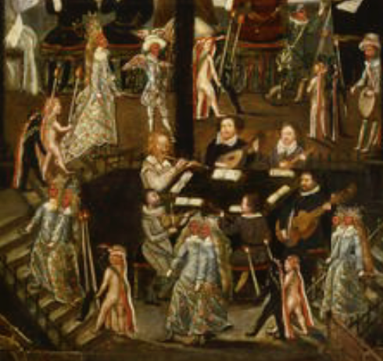

*Torch bearers in the Unton portrait*

**T1.** Arbeau 1589, f. 86v *Bransle de la torche* - arrangement of melody - C 55

**T2.** D-B N 479, f. 16v-17r *Branle de la Torche* - F 58

**T3.** CH-SO DA 111, f. 44v untitled - F 59

**T4.** GB-Lam 603, f. 23r iii *Brawale / Brale de la troche* - F 59

**T5.** I-Lg 774, ff. 11v-12r Il *Ballo della torcia* - G 70

**T6.** Phalèse 1570, f. 78r *Branle de la torche* - guiterna 70

**T7.** F-Pn Rothschild I 411, no. 7 *Allemande de la Torche*  70

- diatonic cittern french tuning

**T8.** B-Br II.275, f. 2r *Ballo della Torcia* - C 71

Instrumental ensemble: Estrées 1559, f. 7v *Bransle de la torche* - à 4

Praetorius 1612, p. 26 *MPC: Bransle de la Torche, fonften* *la Schasse -* à5

**APPENDIX**

An English galliard only known from Rude's print *Flores Musicae* published in Heidelberg in 1600 is included as a page filler as App 1. App 2 is the only known prelude attributed to lutenist Benedict de Drusina, found in a manuscript copied in French tablature and dated 1594 now in theStadtbibliothekBraunschweig. He published two lute books, both printed by Johann Eichorn in Frankfurt: *Tabulatura* of 1556 included four fantasias, vocal intabulations of French, German and Italian songs and motets, as well as passamezzos, saltarellos, and paired German dances. However, as none of the music bears ascription it is not clear whether he composed or intabulated rather than just collected the music. The second book, also *Tabulatura* was published in 1573 and is a transcription from Italian into German tablature of the entire contents of Melchior Neusidler's two Venetian prints of 1566. App 3-6 have titles reminiscent of *Ballet/ Branle/ Allemande de la Torche* above, but are unrelated to it. App 3-5 are similar and based on variants of the same ground (A: beginning I-I-I-I B: beginning V-V-V-V).

**App 1.** Rude II 1600, sig. kk2r *131* index: *Gagliarda Anglica* 28

**App 2.** D-BSstb C 39 2o, no. 26 *Praeambulum Benedict De Drusina* 81

**App 3.** D-Mbs 1511d, f. 15v *La torca* 93

**App 4.** D-Mbs 1511b, f. 6v *La torza* 99

**App 5.** D-Mbs 1511b, f. 19v *El ballo de la torza* 100

**App 6.** Casteliono 1536, f. 22v *Saltarelo chiamato la Torgia* 101

cf. Roy App.59-62, no. 10 *Torza* - instrumental ensemble à4

Commentary to the music in the supplement to *Lute News* 141.[30]

*John H. Robinson - May 2022*

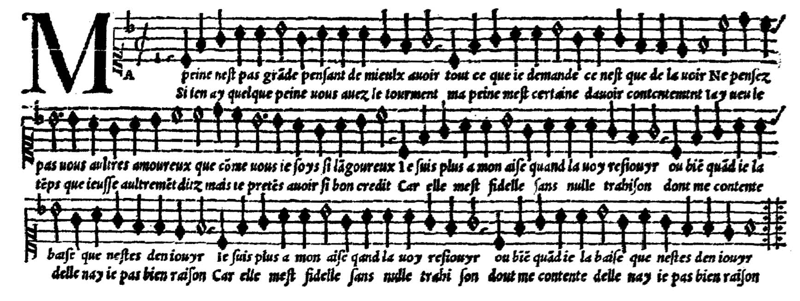

*Superius of Jannequin's 'Ma peine n'est pas grande' in Attaingnant 1545*

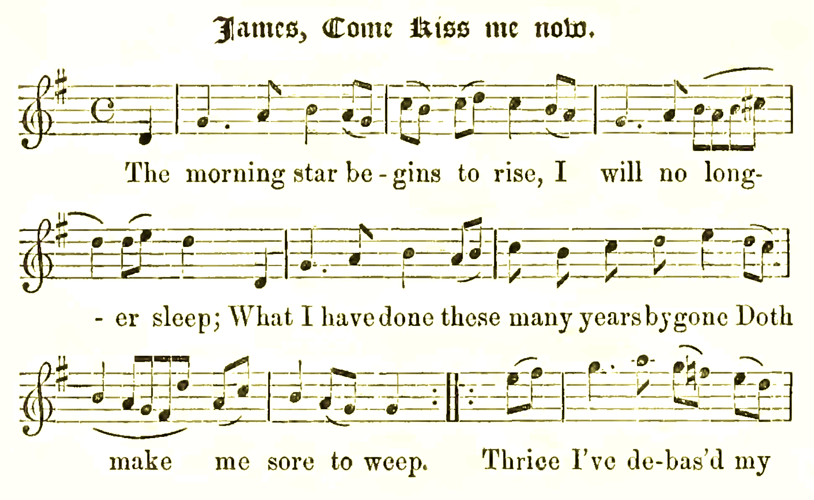

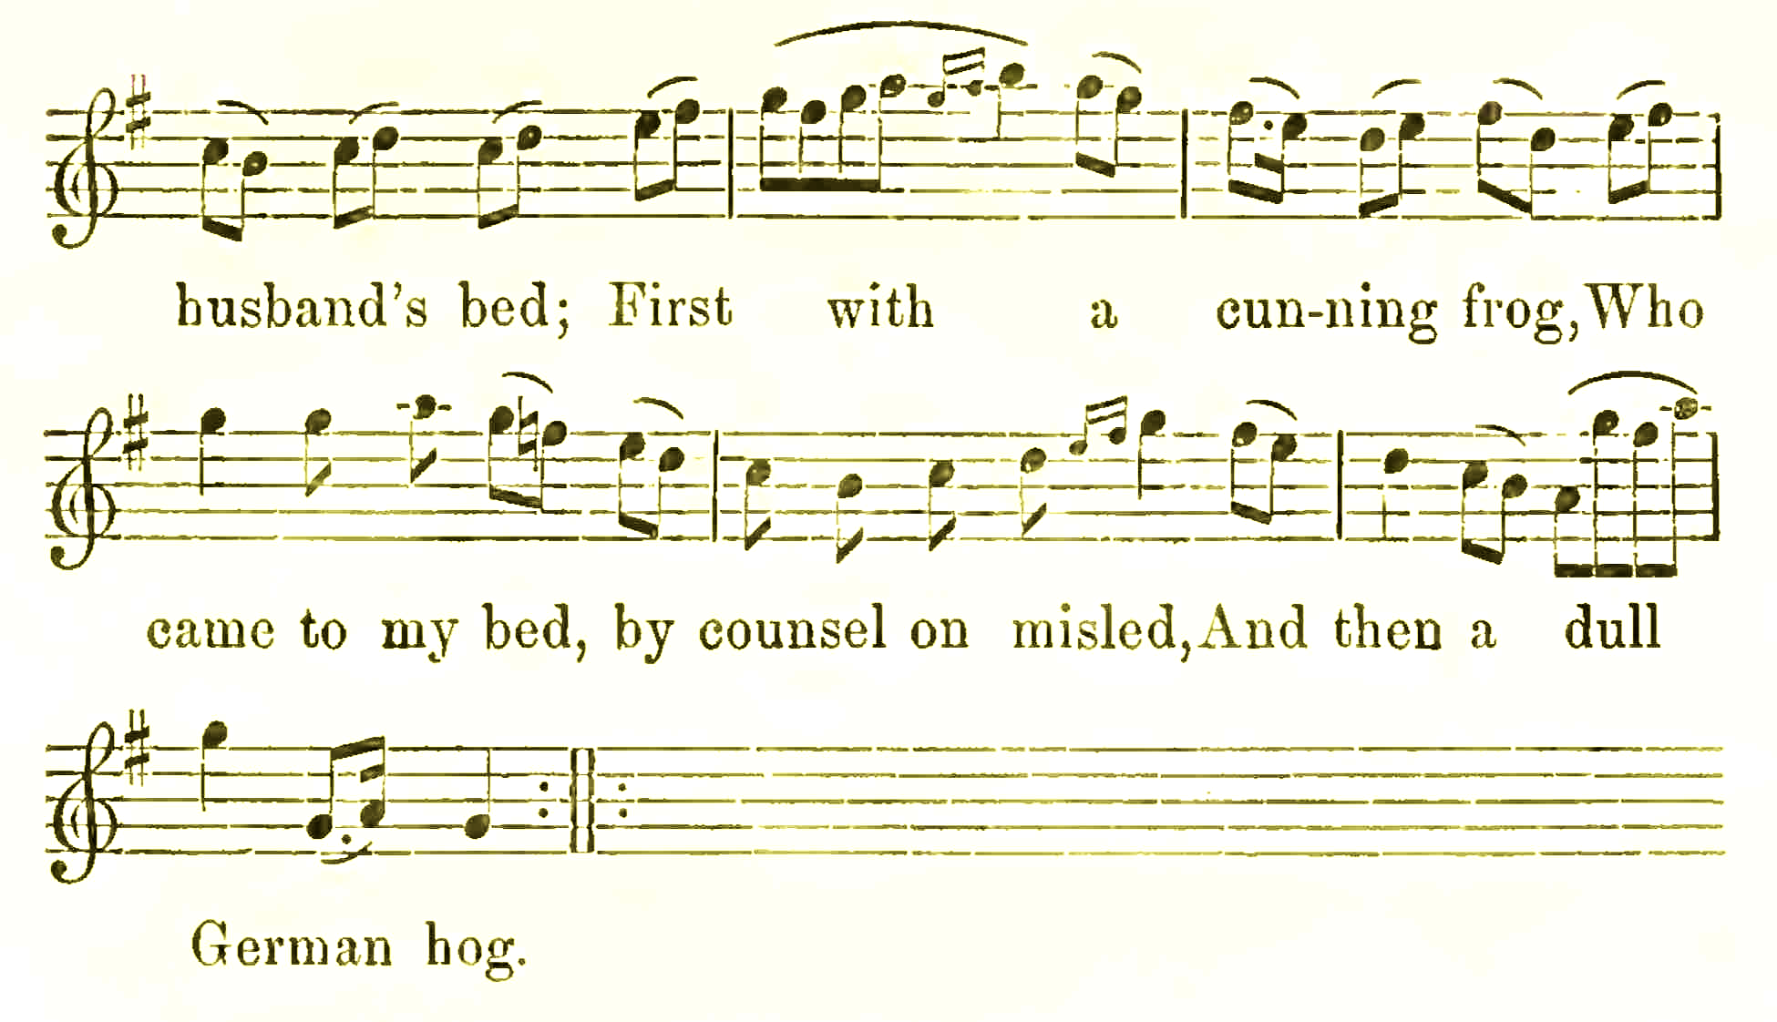

*James Hogg The Jacobite Relics of Scotland 1817*

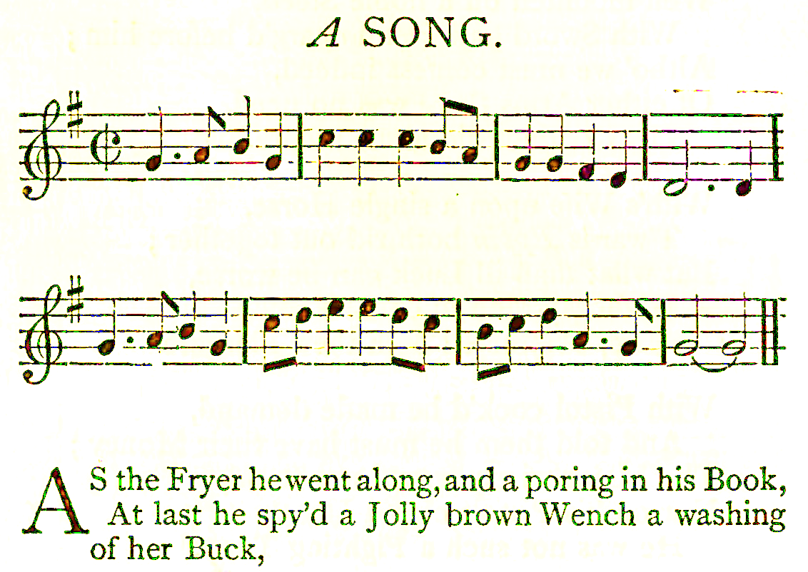

*Thomas D'Urfey's Wit and Mirth, or Pills to Purge Melancholy 1719*

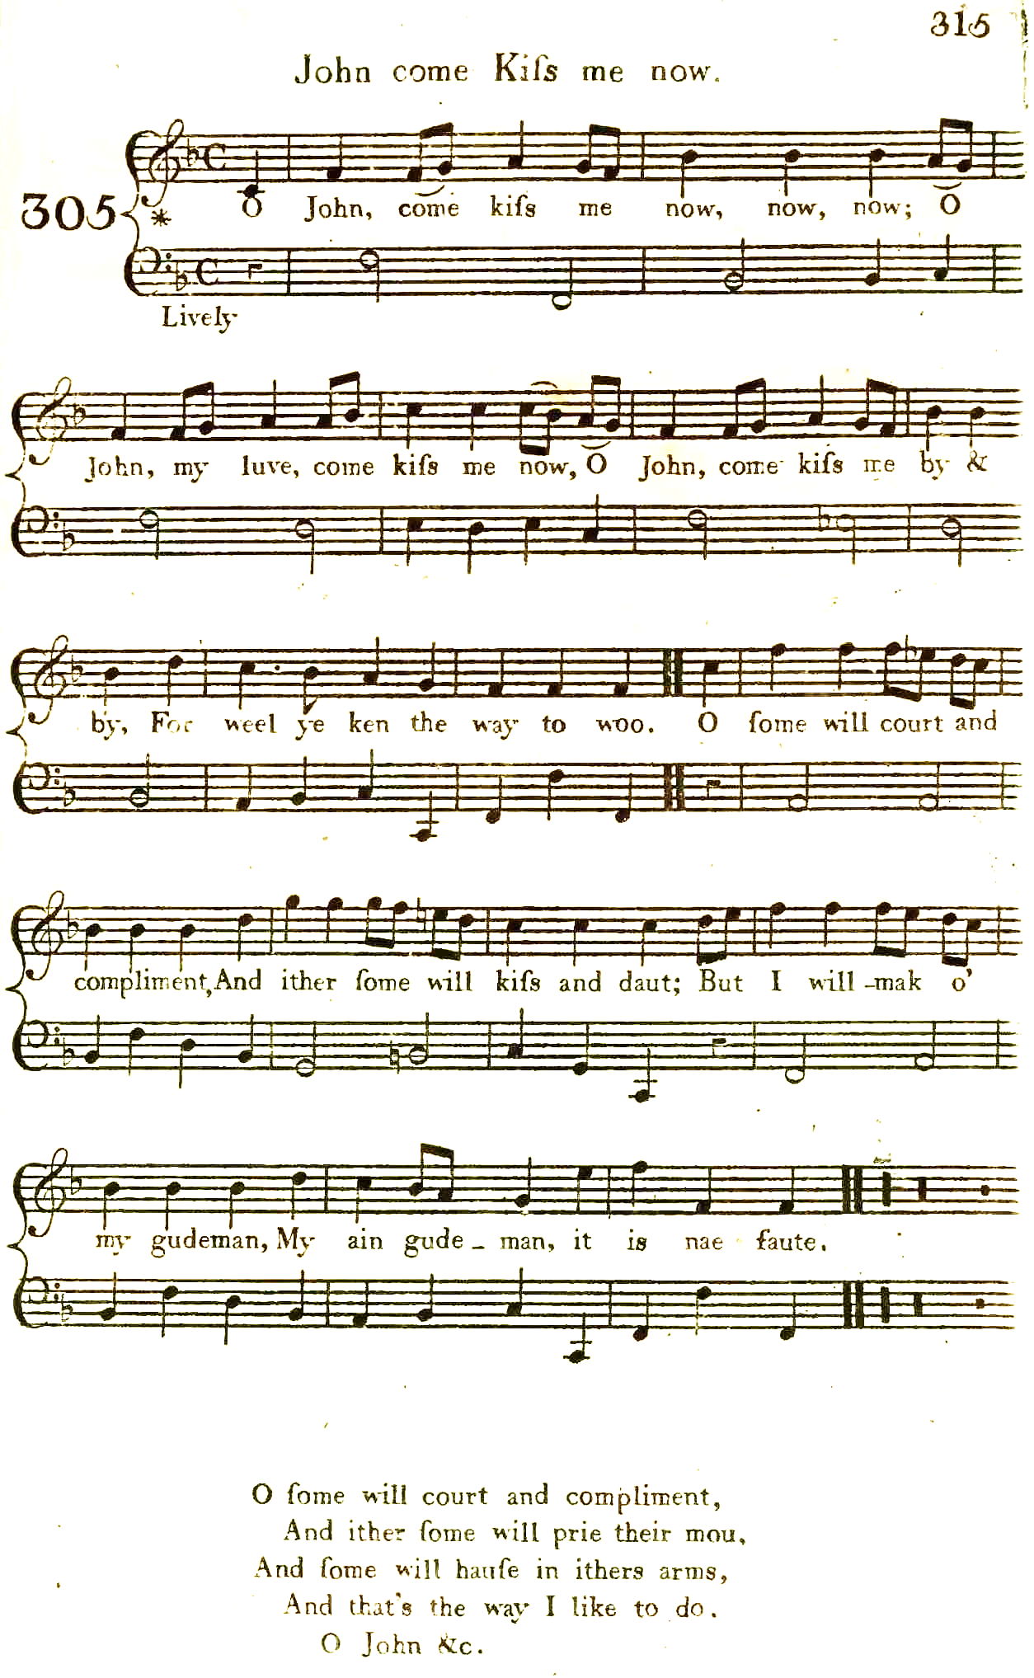

*James Johnson's Scots Musical Museum in 1790*

1. First of six stanzas: 'Worumb seind die Studenten, so leiden woll gehordt, Ja Ja Ja, Ja Ja Ja Ja, sie habn des wirdt sein tochterlein wol zu dem Tantz gefurdt' [Why are the students, who suffer so much, Yes, yes, yes, yes, yes, they have brought his daughter to the dance]. Thank you to Mathias Rösel for sharing his thoughts on the origin of the titles and for bringing the song to my attention.
2. All versions edited for *Lute News* and *Lutezine* 119 (October 2016) & *Lutezine* to *Lute News* 120 (December 2016).
3. The B strain is the same as that of one source of the popular deutsche dantz, *Heckerling und Haberstro*/*Prinzen Dantz*, DK-Kk Thott 4o.841, f. 76v i, and very similar in two other settings, CH-Bu F.X.11, f. 19r *Des Printzen tantz - Proportio* and Heckel Tenor 1556, pp. 132-135 *Der Printzen Tantz - Proportz auff den Tantz* - all sources edited for the *Lutezine* to *Lute News* 130 (July 2019).
4. The common Italian grounds are:

   Passamezo antico/paganina [i-VII-i-V-III-VII-i/V-I or common variant with i at position 5; passomezzo moderno [I-IV-I-V-I-IV-I/V-I]; bergamasca [I-IV-V-I]; cara cosa/la gamba [I-I-IV-III-I-IV-I/V-I]; folia/ pavaniglia/spagnoletto [i-V-i-VII-III-VII-i/V-i]; and romanesca [III-VII-i-V-III-VII-i/V-i].
5. However, he or his printer does not get the structure right - in the duple time section the B strain is four bars and C strain is three bars but in the triple time sections they are five and four bars respectively!
6. The tonalities used in the text are the keys in which the versions appear in the tablature only if played on a lute in G pitch.
7. *Tabulatura Guter gemeiner Deudtscher Tentze, Nicht allein auff einer Lauten in sonderheit, Sondern auch, auff zweyen Lauten, durch Quarten, zusamen, zuschlagen.* [Good, common German dances not only on one lute in particular, but also, on two lutes, (in) fourths, to play together]
8. Marburg, Hessischen Staats-archiv, MS StA MR 115.1 Nr. 631, Waldecker MS - described with facsimile in Sigrid Wirth *Die Laute* XII (2017), pp. 1-38.
9. Thank you to Monica Hall for a copy and for explaining the guitar tablature notation to me. I have not been able to add the up and down arrows to show strummed chords [downstrokes at 1/1, 2/1, 4/1, 6/1, 8/1, 9/1, 10/1, 11/3, 12/3, 13/1, 14/1 & 16/1; upstrokes at 2/2, 4/2, 6/2, 8/2, 10/2, 12/2 & 3, 14/2 & 16/2] in the tablature transcription. Donald Gill 'The de Gallot guitar books' *Early Music* 6 (1978), pp. 79-87. Gallot d'Irlande, and Gallot d'Angleterre elswhere in the same manuscript, are apparently not related to the French lutenists of the same name.
10. John M. Ward *Music for Elizabethan Lutes* (Clarendon 1992), p. 123 fn 335 [and see pp. 124-126] also identified Le forze d'Ercole on the passamezzo antico (edited for *Lute News* 140) as 'occasionally coupled with a descant tune resembling John come kiss me now'. The title of J6 in the Balcarres lute book acknowledges the use of alternative titles *John come kiss me now, or the buffines* for the same music.
11. John M. Ward argues that there was never a ballad text, only the four-line stanza and the tune that served as a starting point for a range of texts and instrumental variations, see John M. Ward 'The Buffons Family of Tune Families: Variations on a Theme of Otto Gombosi's' in: Bell Yung & Joseph S. C. Lam (eds.) *Themes and Variations: Writings on Music in Honor of Rulan Chao Pian* (Cambridge MA, Harvard University Press 1994), Appendix 1: *The "John come kiss me now" tune*, pp. 316-320.
12. Beginning: 'John, come kiss me now, now, now, O John, come kiss me now, John, come kiss me by and by, And make nae mair ado. Some will court and compliment, And make a great ado. Some will make of their goodman, And sae will O of you.'
13. Beginning 'O John, come kiss me now, now, now; O John, my luve, come kiss me now; O John, come kiss me by and by, For weel ye ken the way to woo, O some will court and compliment, And ither some will kiss and daut; But I will mak o’ my gudeman, My ain gudeman, it is nae faute. O some will court and compliment, And ither some will prie their mou, And some will hause in ithers arms, And that’s the way I like to do'.
14. Beginning: 'Preasts content you now, [now, now,] Preasts content you now, For Normond and his company Hes filled the galayis sow'.
15. Hyder E. Rollins 'An Analytical Index to the Ballad-Entries in the Registers of the Company of Stationers of London' *Studies in Philology* 21 (1924), pp. 1-324, no. 2949 'Who loveth to leve in peace and marketh every chanche &c'.
16. All mentioned but sometimes without line or page references [so online texts as a Google e-book is searchable saving avoiding having to read the whole text] in the following modern editions and all confirmed from online facsimiles and full text transcriptions: William Chappell *A Collection of Ancient English Melodies* (1840), pp. 179-180; William Chappell *Popular Music of the Olden Time* (London, Cramer, Beale and Chappell 1855-6), I p. 147/II p. 771; William Chappell, revised H. Ellis Wooldridge *Old English Popular Music* (London, Macmillan 1893/reprinted New York 1961), pp. 268-269; Claude M. Simpson, *The British Broadside Ballad and Its Music*, New Brunswick, Rutgers University Press 1966, pp. 396-398; John M. Ward 'Apropos: The British Broadside Ballad and Its Music' *JAMS* xx (1967), pp. 50-56.
17. Viola da Gamba Society thematic index at: <https://vdgs.org.uk/thematic/>
18. Dedication to Thomas Nashe *The Anatomie of Absurditie* 1589 [bold editorial]: 'So it was that not long since, lighting in company with many extraordinary gentlemen of most excellent parts, it was my chance (amongst other talk which was generally traversed amongst us) to move divers questions as touching the several qualities required in Castiglione’s *Courtier*; one came in with that of Ovid, *Semper amabilis esto*; another stood more strictly on the necessity of that affability which our Latinists entitle *facetus*, & we more familiarly describe by the name of discoursing; the third came in with his carpet devises and told what it was to **tickle a Citterne, or have a sweet stroke on the Lute**, to dance more delicately, and revel it bravely. The fourth, as an enemy to their faction, confuted all these as effeminate follies, and would needs maintain that the only adjuncts of a courtier were scholarship and courage, returning picked curiosity to paltry scriveners and suchlike, affability to Aristippus and his crew, **citterning and luting** to the birthright of every sixpenny slave, and to conclude, dancing & revelling to every tailor’s holiday humour'.
19. Those that are untitled could have been known to the copyists by any of the alternative titles (for example did Mainerio think he was setting the English John come kiss me now or Buffons?). B6 in an Italian lute print includes *il Bufon* in the title but the tune is unrelated and it is set to a different ground.
20. Ward 1994, *op cit.,* pp. 290-357.
21. For a detailed analysis of the grounds used for most but not all of the cittern sources here see Ward 1992, *op cit.*, pp. 125-126.
22. Two of eight fragmentary pages, one now at the Royal Academy of Music, London, and the other at Pennsylvanian University, from the otherwise lost Le Roy *An instruction to the Gitterne* 1569?/reprinted Rowbotham - facsimile pages in Christopher Page *The Guitar in Tudor England* (Cambridge University Press 2015), chapter 4.
23. The passamezzo antico and romanesca only differ in the first bar, i for the pa and III for the romanesca.
24. ToddLane 'The lute quartets in the Thysius lute book' *Journal of the Lute Society of America* 22 (1989), pp. 28-59.
25. Thank you to Jean-Marie Poirier for his analysis of this as a possible quintet.
26. Douglas Alton Smith *30 Easy Pieces for Renaissance Lute* (Lübeck, Tree Editions 1995).
27. Wolfgang Meyer & Ekkehard Schulze-Kurz *Die Lautenquartette aus dem Thysius-Lautenbuch Herausgegeben* (München, Lundgren Edition *c.*2005), no 12 (where the parts are edited to fit) - thank you to Jean-Marie Poirier for bringing this edition to my attention.
28. *Edward Hall's Cronicle containing the History of England* editions of 1548/1550(modern edition, London, J. Johnson 1809, p. 526).
29. In fact more like the tune of *Forze d'Hercule*, see settings in supplement to *Lute News* 140 (Decemnber 2021).
30. **Commentary for the tablature in Lute News 141: Ballard part 2: 28a.** double bar lines between strains absent; no changes. **28b**. double bar lines between strains absent; 1/2 - a10 instead of a7; 30/1 - a7 absent; 48/3 - a6 instead of a7; 48/4 - d1 instead of b1; 48/between 5-6 - b1a4 crossed out. **28c.** double bar lines between strains absent; no changes. **28d.** 1/2, 18/1, 24/1 - a8 instead of a7; 8-9, 27-28 - bar lines absent; 10/3 - crotchet displaced a note to the right; 15/1 - minim instead of crotchet; 15/3 to 16/1 - crotchet c4 bar line minim d3 absent; 17/1 - minim instead of dotted minim; 28/1 - fermata d3 absent. **29a.** double bar lines between strains absent; 67/1 - a7 instead of a8. **29b.** double bar lines between strains absent; 15 - bar absent and substituted from D-Ngm 33748/I, f. 27r; 32/1 - b2b3d4 instead of b1b2d3; 34/3 - c3 instead of b3. **29c.** double bar lines between strains absent; 39/3 - a4 added; 40/1 - fermata a4 absent. **30a.** double bar lines between strains absent; 39-40 - two bars omitted and reconstructed based on bars 19-20; 54 - bar omitted. **30b.** /a, //a, ///a instead of a, /a, //a for 7F, 8E, 9C; double bar lines between strains absent; anacrusis-1, 20-21, 35-36 - bar lines absent; 3/1 - minim instead of dotted minim; 8/1-4 - minim 3 quavers instead of 2 crotchets 2 quavers; 20/2 - crotchet f1 absent; 22/1 - h1 instead of k1; 29/1-2 - crotchet minim instead of minim crotchet; 30/2 - a instead of /a for 7F; 31/2 - a7 instead of 9C; 31/2 - a7 instead of a9; 35/2 - crotchet a9 absent; 36/1 - fermata d2c4 absent. **30c.** double bar lines between strains absent; no changes. **31a.** double bar lines between strains absent; no changes. **31b.** double bar lines between strains absent; 42/1 - a3 instead of a4; 65/4 - c2 instead of b2; 68/1 - fermata d3c4 absent. **31c.** 10/1 - crotchet absent; 23-24 - double instead of single bar line; 24/1-2 - single instead of double bar line; 32/3 - b2 crossed out; 41/1 - //a instead of /a. **31d.** 29/3 - d5 instead of d6; 36/<1 - d3c4 crossed out. **32a.** double bar lines between strains absent; 89/5 - a10 instead of a9. **32b.** /a, //a, instead of a, /a for 7F, 8E; double bar lines between strains absent; 2/1 - d2 crossed out; 14/3 to 15/2, 16/2, 44/2, 66/5- crotchets absent; 17/6 - quaver d5 absent; 19/1 to 20/3 - minims instead of crotchets; 24/2 - c3 instead of c4; 26/5 - b3 and c4 horizontally instead of vertically aligned; 34/2 - a9 instead of a8; 37-38, 44-45 - bar lines absent; 40/2 - dotted crotchet instead of crotchet; 43/3 - a5 instead of a4; 50-51 - double bar line followed by insertion of 4 redundant bars [= bars 30-32 in A strain repeat of 32a]; 56/2 - dotted crotchet absent; 59/1 - dotted minim instead of crotchet. **32c.** /a, //a, ///a instead of a, /a, //a for 7F, 8E, 9C; 15/1 - scribe changed d3 to g3; 16-17 - double instead of single bar line [in addition to the one a note earlier]; 18/3 - f4 crossed out; 22/2 - c4 crossed out; 22/between 2-3 - b2 crossed out; 22/3 - b4 crossed out; 37-38 - bar line absent; 38/2 - semiquaver instead of quaver; 40/1- a8 crossed out; 51-54 [4 bars] different to the equivalent 51-56 [6 bars] of a/b so that the B strain and its repeat is two bars shorter; 52/2 - d4 crossed out; 52/3 - c4 changed to d4; 53/1 - d6 crossed out; 62/1-6 - a8-d1-a1-b2-a1-b1 changed to b6-d3-b3-e4-d2-b2; 62/4 - e4 instead of d4; 63/1-6 - b6-b2-d3-a2-b2-a2 changed to d6-d2-b2-d2-a2-b3; 67/1 - b2 crossed out; 67/3 - d3 insteadof d4; 71/6 - c5 instead of d2; 72-73 - two bars omitted. **33a.** double bar lines between strains absent; no changes. **33b.** double bar lines between strains absent; anacrusis/1, 45/2 - crotchets absent; 15/2, 47/2 - a6 instead of a5; 27/4 - quaver d5 absent; 34/3 - a6 absent; 40/3 - g4 instead of d4; 45/1 - a7 instead of a8. **34a.** double bar lines between strains absent; 37/2 - c2 added; 38/3 - d4 instead of a2; between 38-39 - extra bar added of crotchet b2c4 dotted crotchet b2b3a4d6 quaver a2. **34b.** /a, //a, ///a instead of a, /a, //a for 7F, 8E, 9C; double bar lines between strains absent; 8-9, 30-31 - bar line absent; 14/3 - crotchet instead of dotted crotchet; 36/4, 63/1-3 - crotchets absent; 37/3 - a7 instead of a6; 46/3 - dotted minim instead of dotted crotchet; 55/2 - a9 instead of a8. **35a.** double bar lines between strains absent; no changes. **35b.** /a, //a, ///a instead of a, /a, //a for 7F, 8E, 9C; double bar lines between strains absent; 7/1 - d6 instead of d5; 22/3 - dotted crotchet absent; 23/1-3 - crotchets absent; 38/2 - a6 displaced to the left of a2c3 and dotted crotchet absent; 54/4-5 - quavers instead of semiquavers; 55/3 - minim instead of crotchet. **36a.** double bar lines between strains absent; 70 - extra bar in the division compared to the B strain but the melodic sequence seems to require it. **36b.** double bar lines between strains absent; 19-20, 28-29, 68-69 - bar lines absent; 39/1 - a7 instead of a8; 59, 79 - bars omitted and substitued from 36a (but better without bar 79). **John come kiss me now: J1.** 16-17 - bar line absent; 17 - fermata a4 absent. **J2.** some notes of the original omitted or raised an octave. **Appendix: App 1.** 1/1 - c1 absent; 4-5, 12-13 - double instead of single bar lines; 6-7, 7-8, 14-15 - bar lines displaced a note to the left; 10/1 - crotchet instead of dotted minim; 10-11 - bar line absent; 14/1 to 15/3 - crotchets instead of minims. **App 2.** rhythm signs entirely absent; bar lines absent except single at 4-5, 12-13, 14-15 and double at 8-9; 15/1 - a5 absent. **App 3.** 11/1 - d1 absent; 13/1 - d6 instead of d7; 16/1 - minim instead of crotchet. **App 4.** German tablature; no changes. **App 5.** German tablature; 7/1-2 - minims instead of crotchets. **App 6.** 1/1, 1/7-8, 2/4 - crotchets instead of quavers; 2/6 - crotchet a5 absent; 6-7 - bar line displaced a note to the right; 7/1 - minim instead of crotchet; 7/2 to 8/6 - rhythm signs absent; 7-8 - barline absent. **App 7.** no changes.